6.86: Your friend’s average acceleration is
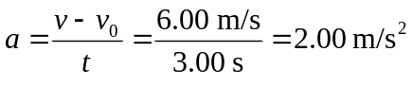
Since there are no other horizontal forces acting, the force you exert on her is given by

Her average velocity during your pull is 3.00 m/s, and the distance she travels is thus 9.00 m. The work you do is 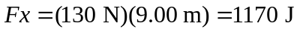, and the average power is therefore 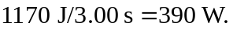 The work can also be calculated as the change in the kinetic energy.

